**Green Supplier Selection using TOPSIS and Machine Learning**

This project aims to develop a systematic approach to evaluate and rank suppliers based on their environmental sustainability practices using the TOPSIS method, followed by implementing machine learning models for predictive analysis of suppliers' green ratings.

This project was made with the following objectives in mind:

* To cater to the needs of organisations to select a sustainable supplier
* To evaluate different suppliers based on their performances and internal weights applied on each expert (evaluator).
* To predict the green image of a supplier and categorise it as whether it is a green supplier or not based on ML predictive classification techniques.
* Provide actionable insights and recommendations for selecting environmentally friendly suppliers.

**3. Detailed Timeline with Milestones**

| **Milestone** | **Description** | **Completion Date** |
| --- | --- | --- |
| **1. Project Initiation** | Define project scope and objectives | September 10, 2024 |
| **2. Data Collection** | Gather data on suppliers, including sustainability metrics. | September 17, 2024 |
| **3. Data Preparation** | Clean and preprocess the data; handle missing values. | September 24, 2024 |
| **4. TOPSIS Implementation** | Develop and implement the TOPSIS algorithm. | October 1, 2024 |
| **5. Machine Learning Model** | Train machine learning models (e.g., Random Forest, KNN). | October 15, 2024 |
| **6. Model Evaluation** | Evaluate models using classification metrics; tune hyperparameters. | October 22, 2024 |
| **7. Results Analysis** | Analyse TOPSIS results and ML predictions; visualise findings. | October 29, 2024 |
| **8. Report Writing** | Compile findings into a comprehensive report; prepare presentation. | November 5, 2024 |
| **9. Final Review and Submission** | Review project outcomes and submit final report. | November 10, 2024 |

**4. Description of Deliverables**

* **Deliverable 1:** **Data Set**
  + A cleaned and processed dataset containing supplier information and sustainability metrics.
* **Deliverable 2:** **TOPSIS Results**
  + A detailed report summarizing the rankings of suppliers based on the TOPSIS analysis, including visualizations (e.g., scatter plots, bar charts).
* **Deliverable 3:** **Machine Learning Model**
  + A trained and validated machine learning model (e.g., Random Forest, KNN) capable of predicting supplier green ratings based on input features.
* **Deliverable 4:** **Final Report**
  + A comprehensive project report detailing objectives, methodology, results, analysis, and recommendations for supplier selection, along with supporting visualizations.
* **Deliverable 5:** **Presentation**
  + A PowerPoint presentation summarizing the project findings and recommendations, suitable for stakeholders and decision-makers.

**5. Risks and Mitigation Strategies**

| **Risk** | **Mitigation Strategy** |
| --- | --- |
| Data quality issues | Implement rigorous data cleaning and preprocessing steps. |
| Model performance not meeting expectations | Continuously evaluate and fine-tune models based on feedback. |
| Time constraints | Regularly monitor progress and adjust timelines as needed. |

**Green Supplier Selection Project Technical Documentation**

**Project Title: Green Supplier Selection Using TOPSIS and Machine Learning**

**Author:** Bhavya Yajush Awasthi

**Date:** 7/11/24

**1. System Architecture and Design**

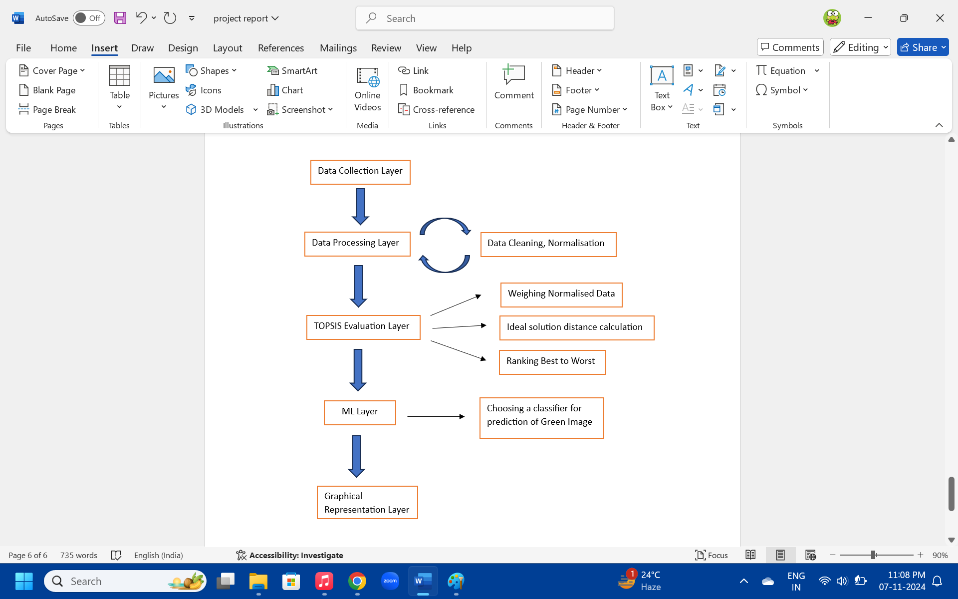

* **Data Collection Layer**: Gathers supplier data from sources such as CSV files and hypothetical datasets.
* **Data Processing Layer:** Handles data cleaning, preprocessing, and feature engineering.
* **TOPSIS Evaluation Layer**: Implements the TOPSIS method to score and rank suppliers based on set criteria.
* **Machine Learning Layer**: Utilizes ML models to predict green ratings based on historical supplier data.
* **Graphical Representation Layer**: Provides tools for data visualization and generates detailed reports.

**2. Key Components and Modules**

**Descriptions of each layer and specific functions:**

* **Data Collection Layer:**
  + **Sources and formats of supplier data.**
* **Data Processing Layer:**
  + **Handles data cleaning, feature engineering, and preparation for analysis.**
* **TOPSIS Evaluation Layer:**
  + **Processes weighted criteria and calculates scores for ranking suppliers.**
* **Machine Learning Layer:**
  + **Includes model selection, training, and evaluation for predicting green ratings.**
* **Visualization and Reporting Layer:**
  + **Components for scatter plots, bar charts, and report generation.**

**3. API Documentation (if applicable)**

**If APIs or modular functions are used, document each endpoint or function:**

* **Endpoint or Function Name**
* **Input Parameters**
* **Output Structure**
* **Usage Example**

**4. Setup and Usage Instructions**

**Steps for setting up and using the project:**

* **Environment Setup:**
  + **Required software, libraries, and dependencies.**
* **Installation Steps:**
  + **Commands for installing dependencies, e.g., using pip or requirements.txt.**
* **Usage Instructions:**
  + **Guide for running data processing, TOPSIS evaluation, model training/testing, and visualizing results.**